What Are The Consequences of A Skewed Sex Ratio?

Kathleen Anderson, Yizhen Wu

University of Colorado Boulder, INFO4602

[kaan8907@colorado.edu](mailto:kaan8907@colorado.edu), [yiwu2153@colorado.edu](mailto:yiwu2153@colorado.edu)

1. **ABSTRACT**

With the continuous expansion of the world’s total population, the per capita resources of our human beings are declining. In order to maintain social stability and rational distribution of resources, many countries have to introduce policies to control the population. Countries in Asia, northern Africa, and the Middle East have much higher ratio differences from male to female populations, due to the preference of birthing males as opposed to females. Because of this, it has led to an excess in males with no partner to find, and a number of “missing women.” This not only has social and cultural consequences on the man but the woman as well. We’re going to talk about how the data we collect can tell a story much bigger than the numbers. We are particularly focusing in on China, Yizhen’s homeland and a timely conundrum for the future of family lineages.

1. **INTRODUCTION**

Although women naturally live longer than men, there is still a skewed sex ratio in many countries. “The evidence for sex-selective abortion and discrimination against girls is now strong across several countries. Not only does the increase in sex ratios coincide with the availability of prenatal sex determination technologies, but there is also clear evidence from studies investigating the use and promotion of such methods” ([Our World In Data](https://ourworldindata.org/gender-ratio#biology-or-discrimination-which-countries-have-skewed-sex-ratios-at-birth)). When prenatal diagnosis was introduced, medical abortion was legalized a year later. We wish that could have been a coincidence, but medical abortion was probably a byproduct of this new discovery. “As a result, roughly 50 million excess males under the age of 20 today reside in those two countries. And at least in China, that wave has not yet crested” ([*wired.com*](https://www.wired.com/story/first-big-survey-of-births-finds-millions-of-missing-women/)). Besides Brazil and Mexico, India has the 3rd largest homicide rates in the world. The problem is that the culture didn’t view sex-selective abortion as unethical, and thought it was just a good way to balance out the population. This is obviously useless when there is now an extreme shortage in those countries. The problem with male preference is the number of [missing](https://www.vice.com/en_us/article/kzeaxv/where-30-million-missing-girls-in-china-actually-went) [women](https://www.cnn.com/2016/12/01/asia/china-missing-girls/index.html) and then single men. Younger men face difficulty finding women because the still single older men are still out there hopelessly looking. Looking for love will be less authentic and more about monetary benefit for women, as they’ll only go to the wealthiest, having an unnecessary plethora of options. The most self-refuting concept of all is that when there are too many single men to find a relationship in the shortage of women, carrying along the family name won’t even be able to happen. Another issue with this concept of male preference is how it affects women. Women are solely viewed as wives. Their opportunities are often shut down earlier, and they aren’t valued as much or taken as seriously; nevertheless, women feel a lot more pressure than they should. In this [article](https://www.scmp.com/business/china-business/article/2188933/chinese-women-earn-fifth-less-men-and-gap-widening-fast) it states that women in China make only a fifth (20%) of what men make for doing the same occupation/position.

1. **MORE WORK**

In many developing countries, many families still maintain traditional, backward thinking: having a son is the only way for their family to continue. As a result, many women in these countries have been forced to have an abortion, or even abandoned after giving birth to a baby girl. The blind birth of a son will also bring many social problems, and the imbalance between the male and female makes more and more men unable to find a wife. In China, a movie tells a real story, Blind Mountain. In 1990, a young female college student was abducted into a distant mountain in China to become a wife. All her documents and money were taken away. She was sold to the mountain for 200 yuan by a professional trafficker, where she was forced to marry a man and give birth to a child. Attempts to escape were beaten, and even the police were powerless. This is the consequence of an imbalance between the male and female ratios, disrupted social order, distorted human nature, and the safety of single women cannot be guaranteed. China is just a special example, but it does not mean that these things will not happen in other countries. In an increasingly progressive society, women are beginning to gain the same rights as men and are no longer discriminated against. The root cause is that the ratio of men and women has begun to decrease. The rate of world population growth is also average. But we still need to control population growth. The resources on earth are limited, and the water and food on which humans depend are limited. The larger the population, the fewer resources per capita. Before we can fully use environmentally friendly energy, we should save and keep an eye on the growth rate of the population.

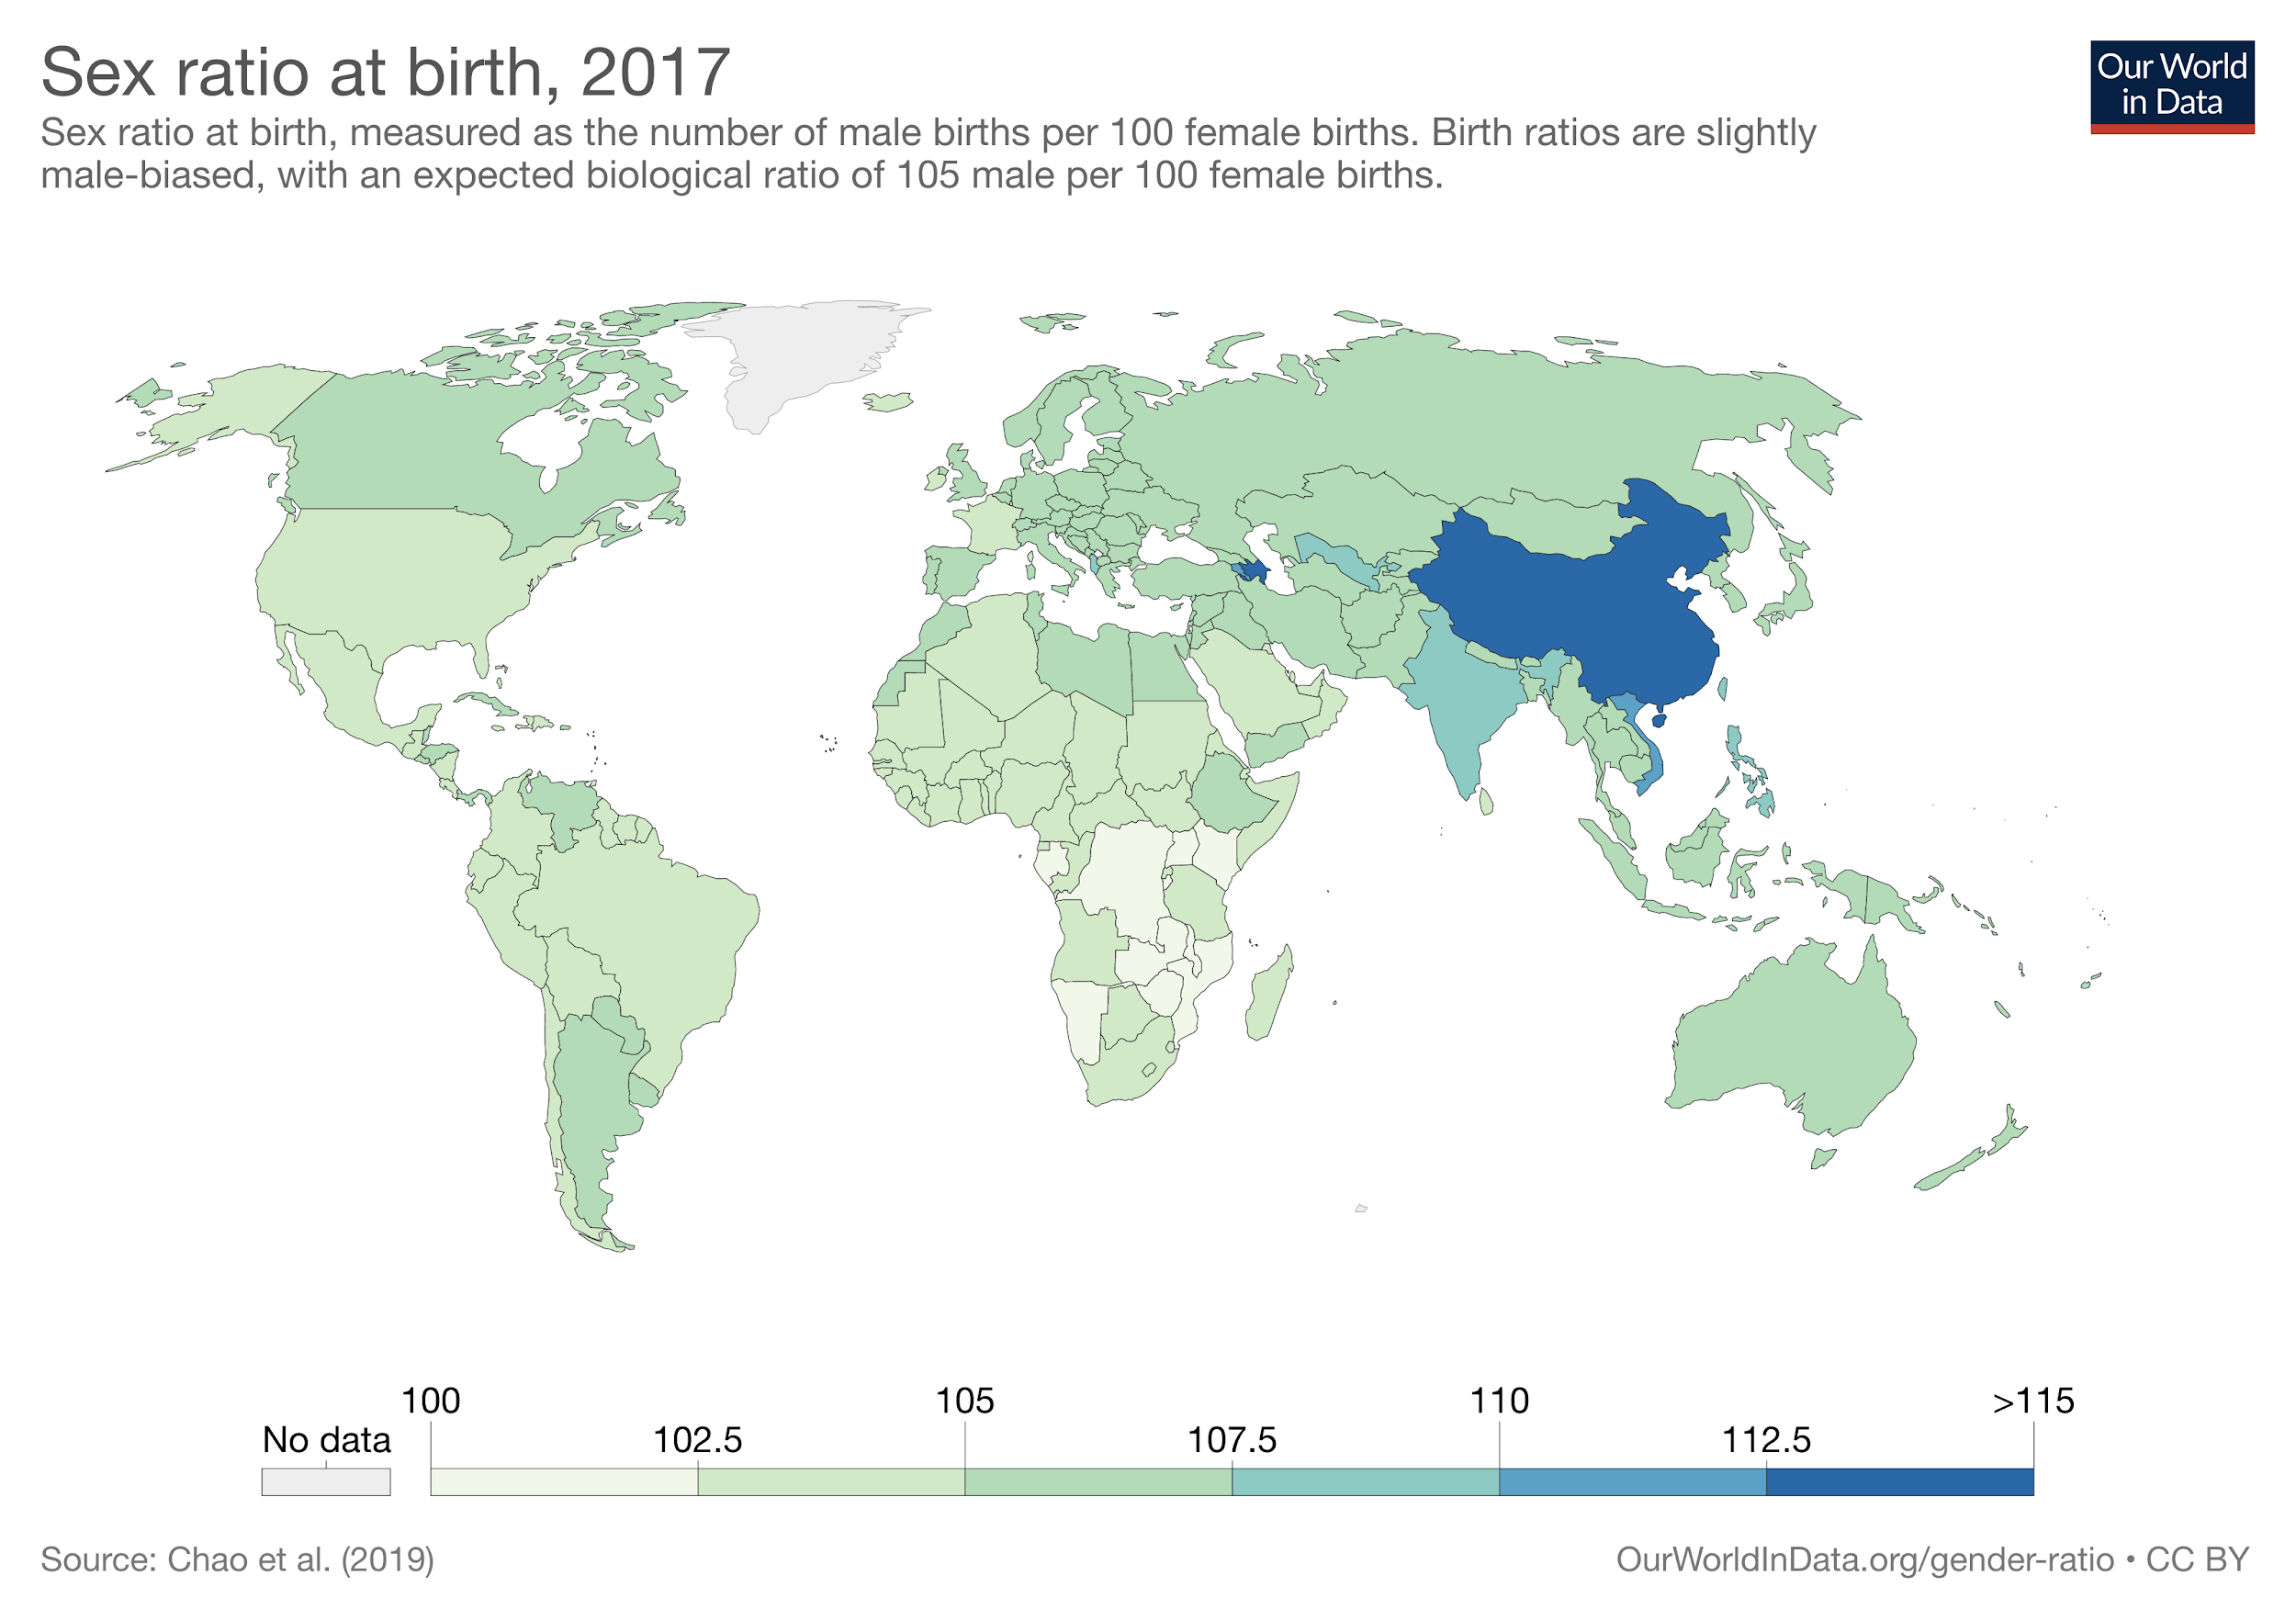

1. **FINDINGS**

China has the highest sex ratio in the world, with 115–116 male births per 100 female births. There is an average ratio of 103 to 107 boys born per 100 girls, and that’s due to the higher probability of miscarrying a female over a male baby; however, countries like China, Pakistan, India, Vietnam and so on purposely make this ratio even more skewed. In India, evidence and data show that parents are likely to keep trying to have children until they have a boy. “At a local level, a study of a large Delhi hospital known for maternal care showed very similar results. The overall sex ratio was male-biased with only 806 girls per 1000 boys. But this got significantly worse when the family already had a daughter: 720 girls per 1000 boys if there were one previous girl and only 178 girls per 1000 boys for two previous daughters” ([Our World In Data](https://ourworldindata.org/gender-ratio#biology-or-discrimination-which-countries-have-skewed-sex-ratios-at-birth)).

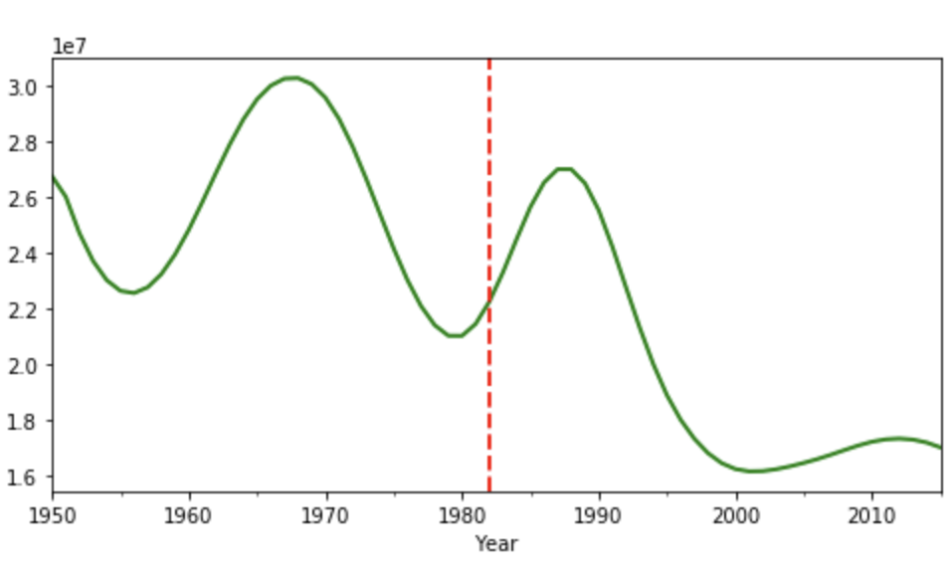

*Annual population grows ratio in China(the red line is the time when China started the one-child policy)*

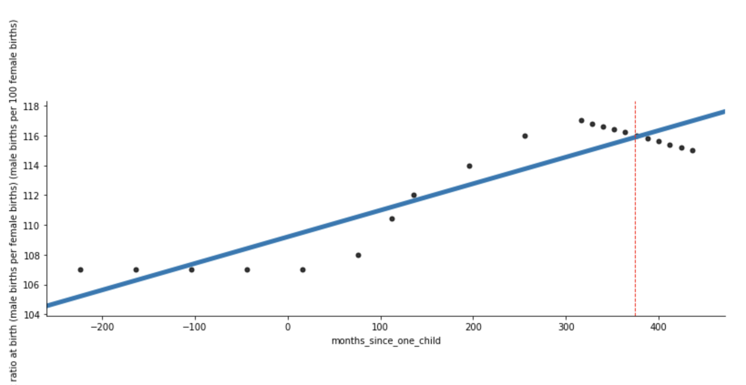

*The gender ratio in China(red line is the time when China started the two-kids policy, 0 refers to the time when China started the one-child policy)*

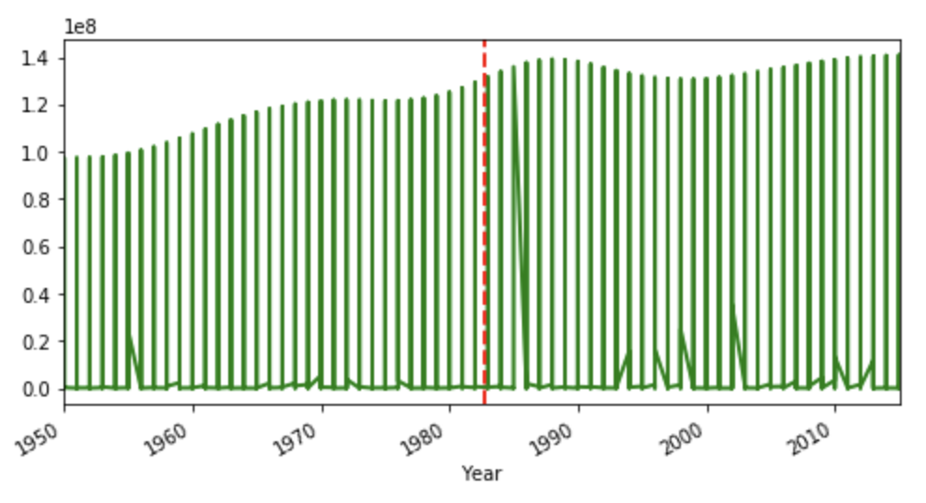

*The annual population ratio in the world (the red line is the time when China started the one-child policy)*

Because our data is from 1950 to 2017. So we think it is very effective to use time series method to make these three data visualizations. In each picture, we have added a red line. This red line is for the audience to see more clearly the changes in China and even the world after the only child (or open second child policy). It is also convenient to compare the data before and after September 1982. In the Chinese sex ratio chart, we also used statistical methods to turn the data for each year into a point. The blue line is an upward line from the starting point, so you can see blue as a contrast line. We could compare it with our actual data.

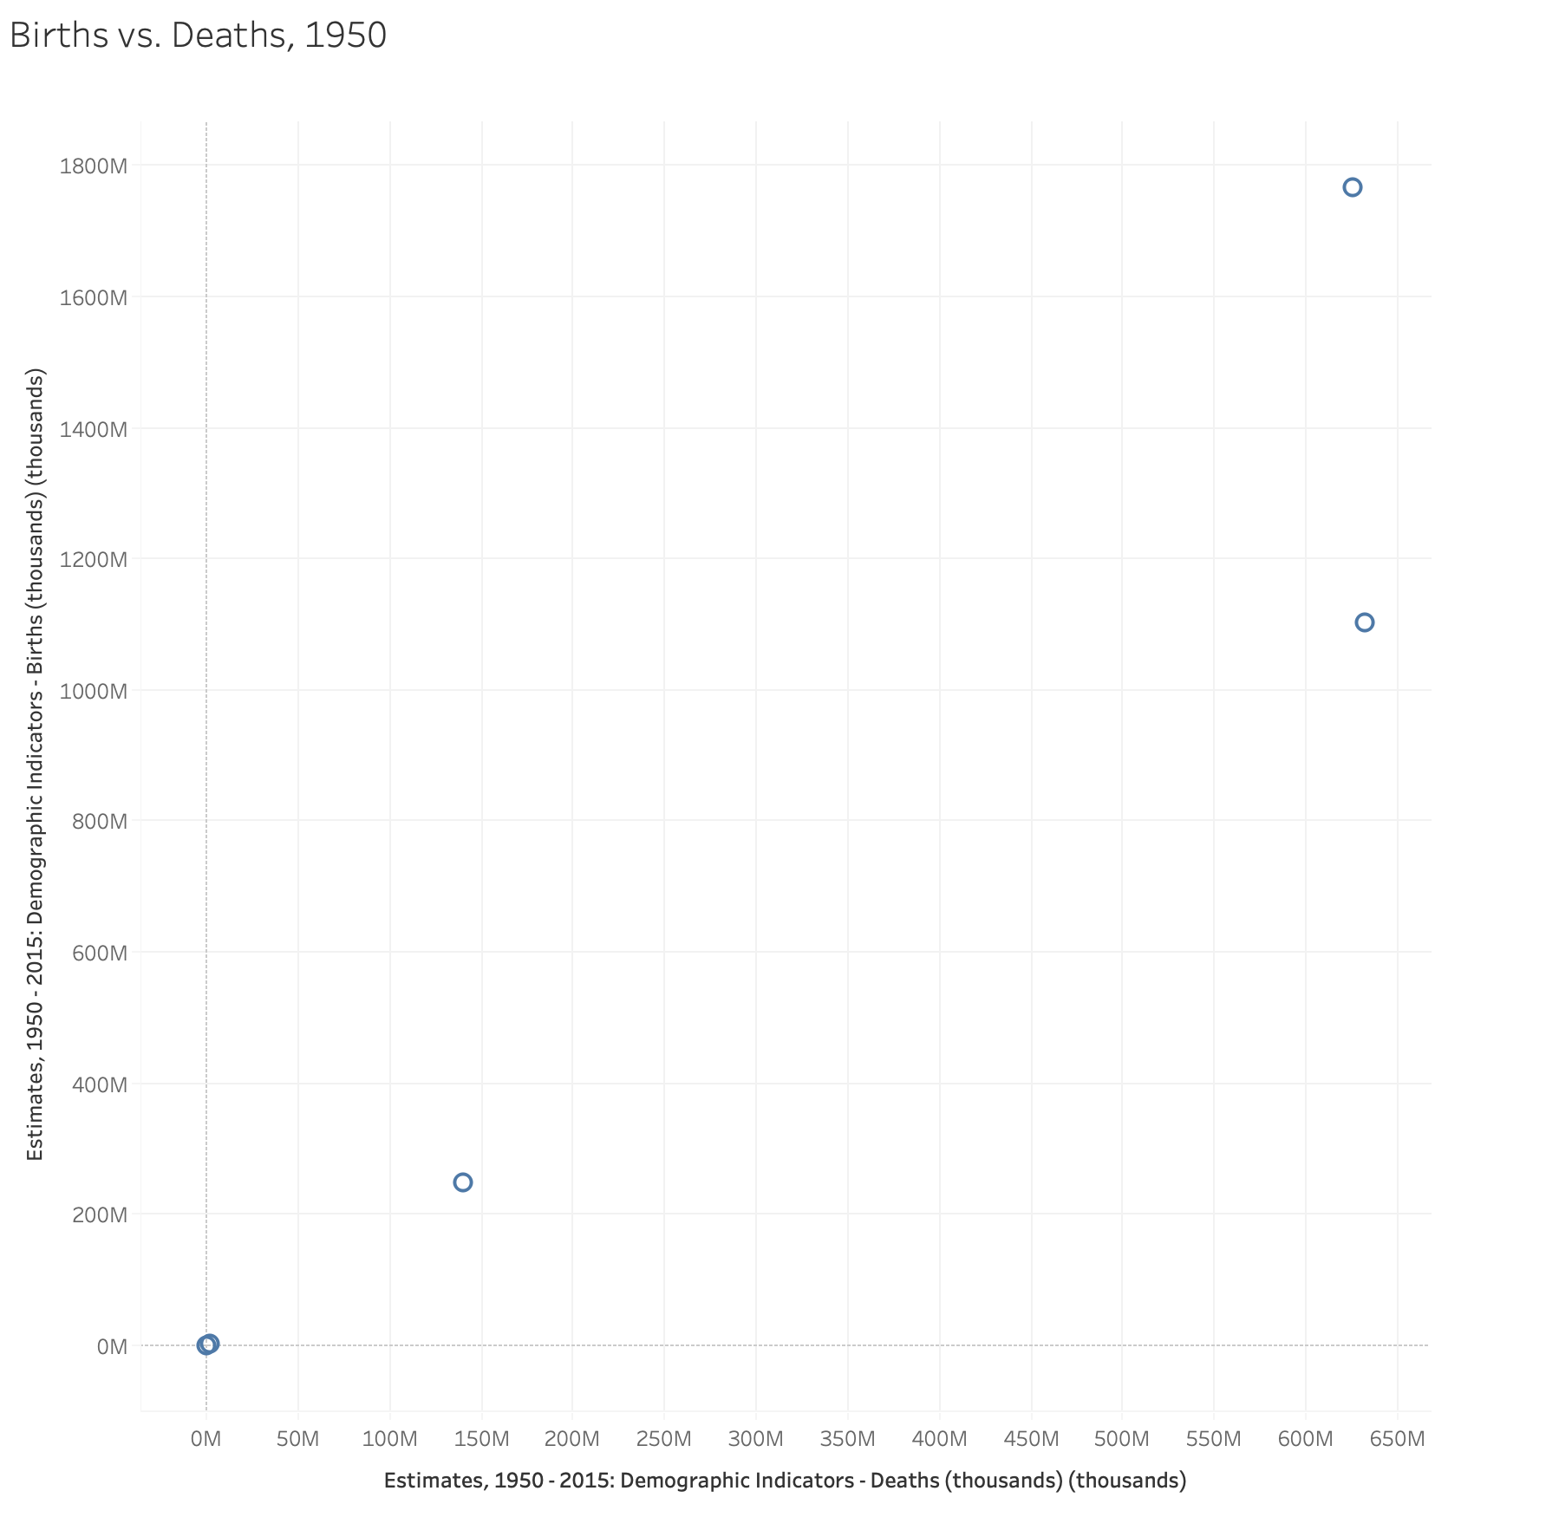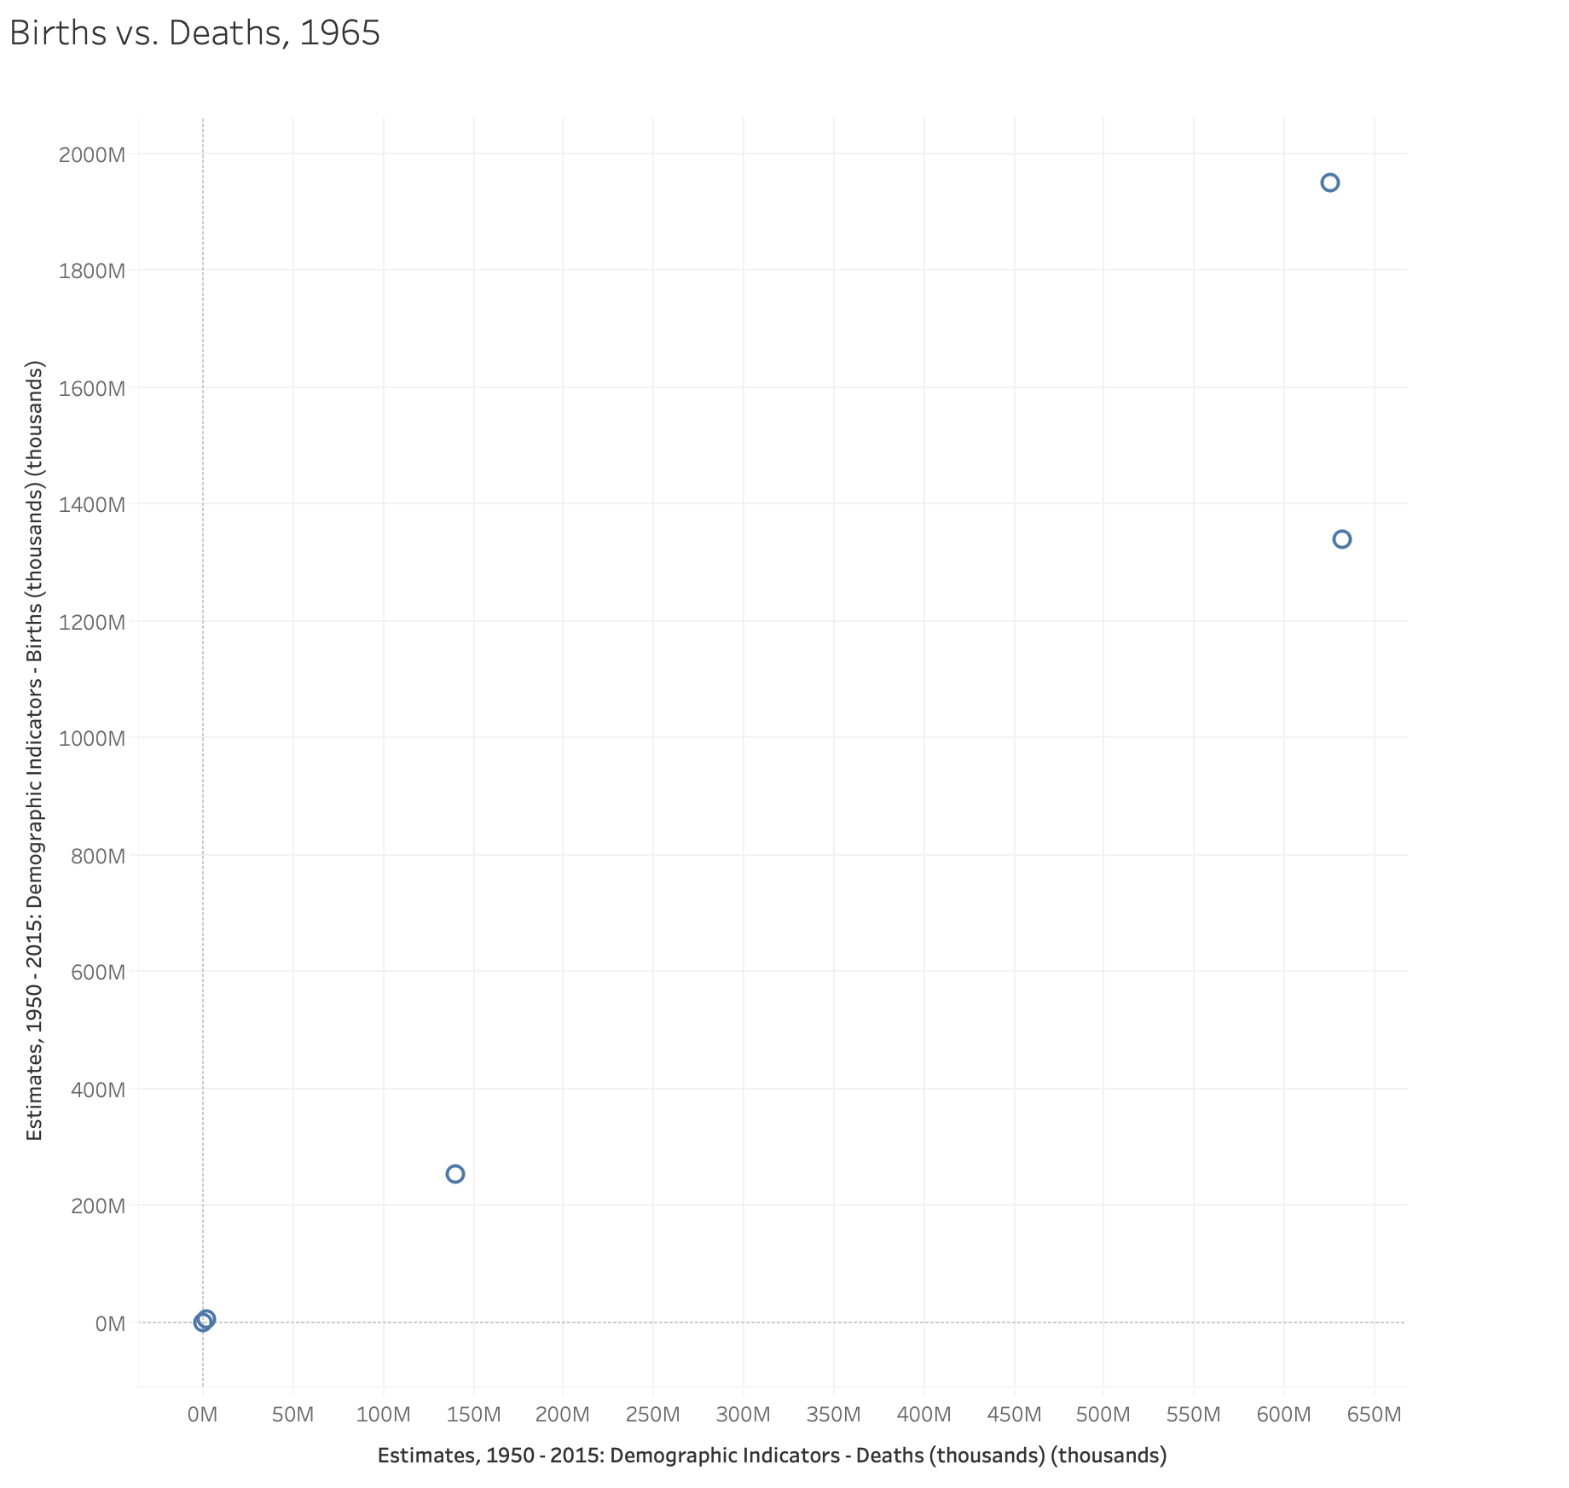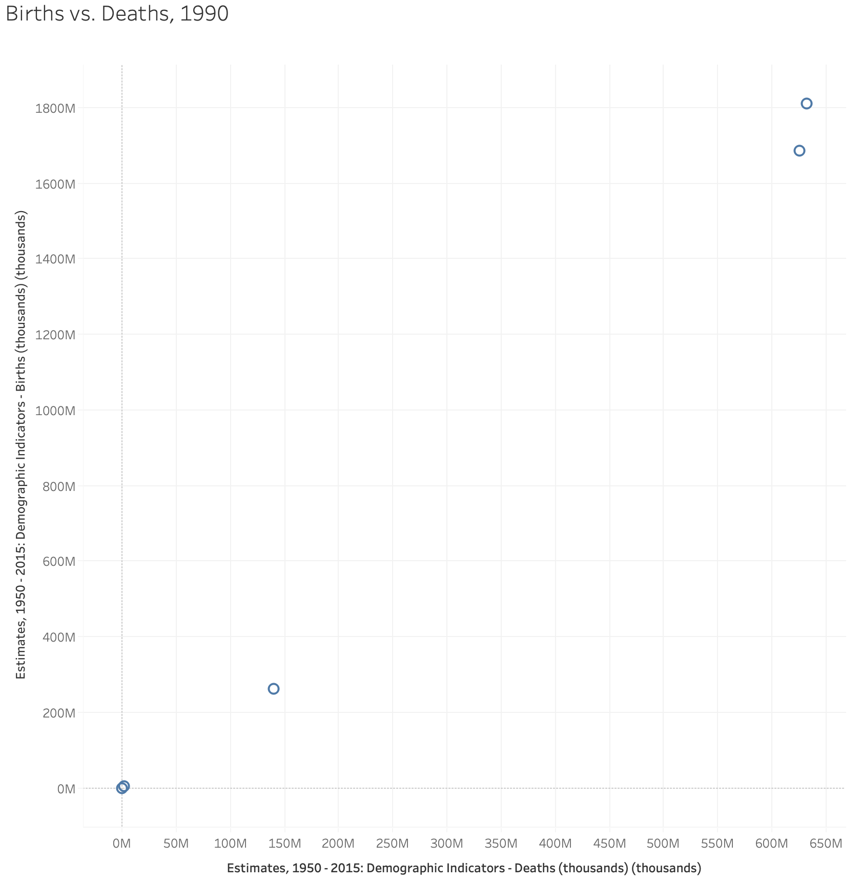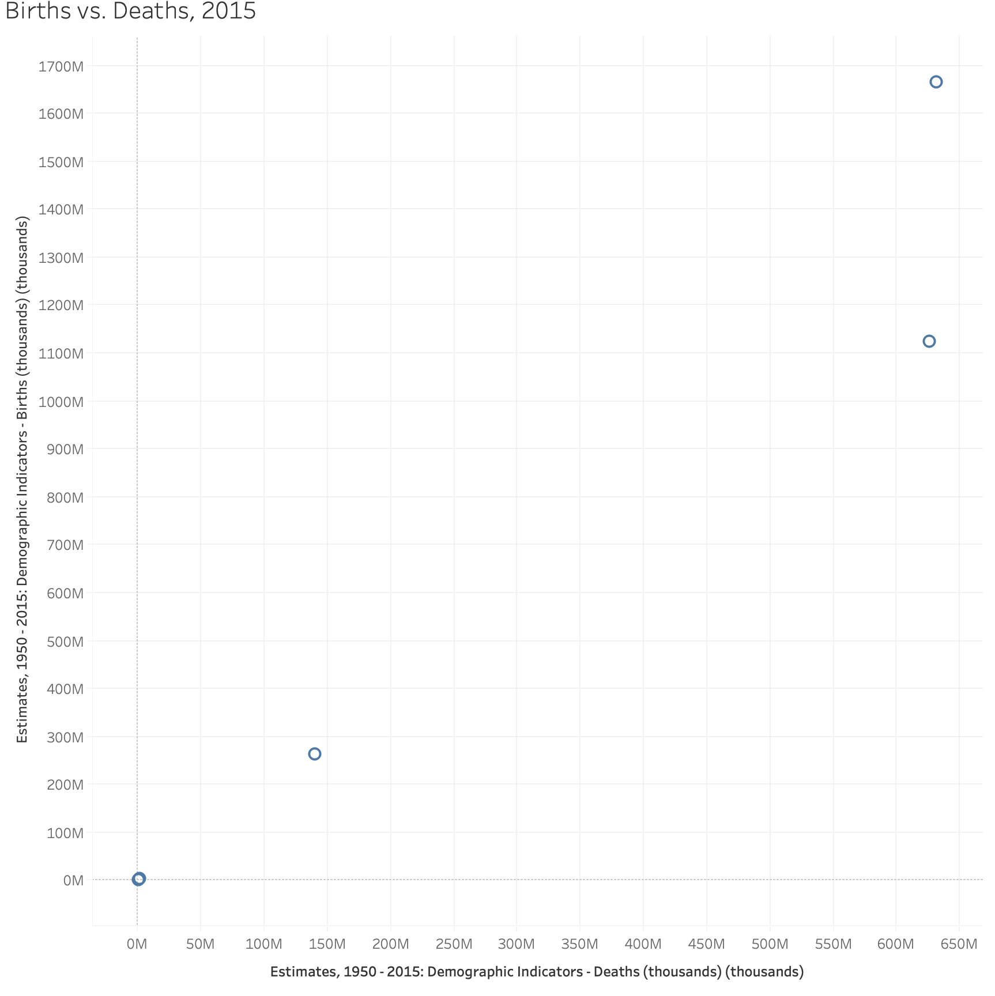

These scatter charts show the upward trend from 1950 to 2015 in not only an increase in births but an exponential increase in deaths. The ratio keeps getting higher between deaths and births, and the sooner the birth rate continues to slow down, the closer those two parallel ends will meet at 1. The countries we chose to visualize were Malta (an island off the coast of Italy), Armenia (located in Eurasia border area), the United States, India, and China. Those countries are listed in the order the plot progresses them in, with Malta and Armenia closest to the origin, and the United States next. India, the second closest to the top, had a spike in births around 1990, and then that number greatly decreased by 2015. China seems to have a lot of consistency with births, but deaths are increasing even more; nevertheless, it is projected that India will soon take over the world’s largest population by 2100.

In order to pursue more effective labor, developing countries like India and China can develop their economies faster and more efficiently. At the beginning of the founding of New China in the last century, due to the impact of World War II China, Mao Zedong (China’s highest tie man at the time) encouraged China to have children. ([A review of population theoretical research since the founding of the People’s Republic of China](https://www.ncbi.nlm.nih.gov/pubmed/12281752)).

Since this database only contains data from 1950, we cannot compare the male to female ratio before Mao Zedong encouraged fertility. But we can still find a lot of interesting things in this picture. Since Mao Zedong blindly encouraged the Chinese people to have children, social resources have not been well allocated. Because of Mao Zedong's policy of encouraging fertility, the Chinese population doubled in a short period of time. This led to the Great Famine of 1961 and it killed an estimated 15 to 30 million people at that time (“[See How the One-Child Policy Changed China](https://www.nationalgeographic.com/news/2015/11/151113-datapoints-china-one-child-policy/)”). After the 1970s, China’s population base reached a peak. Social resources will no longer be able to serve the swollen population, so Deng Xiaoping (Chinese leader in the 1970s) proposed the one-child policy (a couple can only have one child). This can also be compared with our annual birth rate chart. After the one-child policy was officially implemented in September 1982, China’s gender ratio continued to decline. In fact, we were not surprised by this result. There are many abandoned babies in China, and most of them are abandoned. So in those days, many American couples went to China to adopt these abandoned baby girls. Incomplete data statistics, a total of 100,000 baby girls were adopted. Many women even go to the hospital to have an abortion after blindly guessing that they are pregnant with a girl based on the physiological response of pregnancy. The purpose is to have a boy.

1. **CONCLUSION OF FINDINGS**

Sex-selective abortion is alive and well in many parts of the world, some more than others. Since China began to fully implement the one-child policy in 1982, many women have become pregnant again after having a child. In order to comply with this policy, they are not fined. They can only choose to have an abortion. Or there are many women who use sex-selective abortion in order to have a baby. After the one-child policy was implemented, there were 400 million female abortions in China (“[Beijing’s one-child policy is gone. But many Chinese are still reluctant to have more.”](https://www.washingtonpost.com/world/asia_pacific/beijings-one-child-policy-is-gone-but-many-chinese-are-still-reluctant-to-have-more/2019/05/02/c722e568-604f-11e9-bf24-db4b9fb62aa2_story.html)). There could be many reasons as to why the population is decreasing, such as socio-economic factors or minor cultural changes that do not revolve around sex-biases. Because of the one-child policy, many families in rural China treat their daughters as "non-existent children" after giving birth. Parents will not register them, they will not be able to enjoy education and medical benefits. They are "non-existent" in this world, so the Chinese population may be biased in decreasing because there are many "non-existent" children ([“Study finds millions of China's 'missing girls' actually exist”](https://www.cnn.com/2016/12/01/asia/china-missing-girls/index.html)). We, however, must recognize the clear but unspoken evidence that some groups of nationalities, if still holding true to their beliefs that sex-selectivity is ethically “okay,” will eventually become endangered populations.

1. **DETAILED DESCRIPTION**

We conducted research through scholarly and non-scholarly articles, worked with CSV files from [Our World In Data](https://ourworldindata.org/charts), and visualized them in Jupyter notebooks and on Tableau. Justifications for our design elements were through creating a GIF to show progression in births vs. deaths throughout the years of multiple different countries, a time series to show the population differences before the one-child law and after it (red dotted line is the crossover), and a time series to show the annual population in the world. We also conducted a line chart that showed the progression and regression of the gender ratio in China (the red line is the time when China started the two-kids policy, 0 refers to the time when China started the one-child policy).

1. **REFERENCES**

Chinese women 'hold up half the SKY', for 20 per cent less pay. (2019, March 07). Retrieved December 09, 2019, from <https://www.scmp.com/business/china-business/article/2188933/chinese-women-earn-fifth-less-men-and-gap-widening-fast>

Clarke, A., & Serrano, M. (2016, March 01). See how the one-child policy Changed China. Retrieved December 09, 2019, from <https://www.nationalgeographic.com/news/2015/11/151113-datapoints-china-one-child-policy/>

Fifield, A. (2019, May 09). Beijing's one-child policy is gone. but many Chinese are still reluctant to have more. Retrieved December 09, 2019, from <https://www.washingtonpost.com/world/asia_pacific/beijings-one-child-policy-is-gone-but-many-chinese-are-still-reluctant-to-have-more/2019/05/02/c722e568-604f-11e9-bf24-db4b9fb62aa2_story.html>

Jozuka, E. (2016, December 01). The study finds millions of China's 'missing GIRLS' actually exist. Retrieved December 09, 2019, from <https://www.cnn.com/2016/12/01/asia/china-missing-girls/index.html>

Lawson, K. (2016, December 01). ​Where 30 MILLION 'MISSING' girls in China actually went. Retrieved December 09, 2019, from <https://www.vice.com/en_us/article/kzeaxv/where-30-million-missing-girls-in-china-actually-went>

Molteni, M. (2019, April 15). First big survey of BIRTHS FINDS millions of missing women. Retrieved December 09, 2019, from <https://www.wired.com/story/first-big-survey-of-births-finds-millions-of-missing-women/>

Qu, H. (1988, March). A review of POPULATION theoretical research since the founding of the People's Republic of China. Retrieved December 09, 2019, from <https://www.ncbi.nlm.nih.gov/pubmed/12281752>

Ritchie, H., & Roser, M. (2019, June 13). Gender ratio. Retrieved December 09, 2019, from <https://ourworldindata.org/gender-ratio#biology-or-discrimination-which-countries-have-skewed-sex-ratios-at-birth>